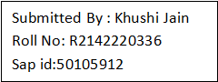

Target1.yml

---

- hosts: devops

user: devops

become: yes

connection: ssh

gather_facts: yes

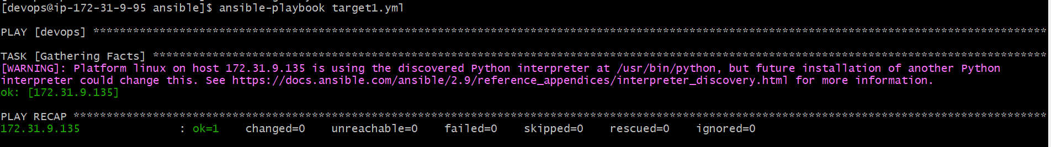

Target 2.yml

---

- hosts: devops

user: devops

become: yes

connection: ssh

tasks:

- name: Install HTTPD

action: yum name=httpd state=present

- name: Install NGINX

action: yum name=nginx state=present

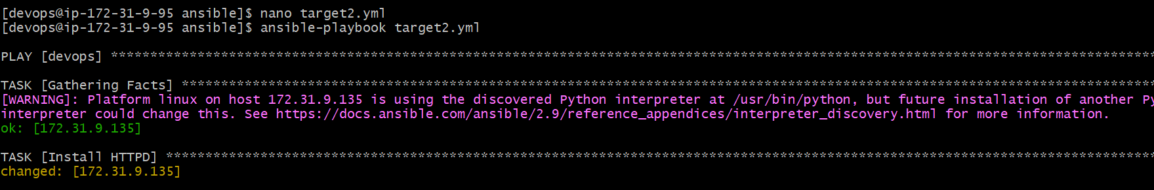

Target3.yml

---

- hosts: devops

user: devops

become: yes

connection: ssh

vars:

pkgname: httpd

currstatus: absent

tasks:

- name: Un-Install HTTPD

action: yum name='{{pkgname}}' state='{{currstatus}}'

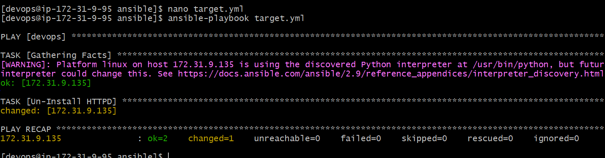

Traget4.yml

---

- hosts: devops

user: devops

become: yes

connection: ssh

tasks:

- name: Debian Family

command: apt-get install apache2 -y

when: ansible_os_family == "Debian"

- name: RedHat Family

command: yum install httpd -y

when: ansible_os_family == "RedHat"

